THIS DRAWING REMAINS THE PROPERTY OF DESCON LTD AND MAY NOT BE COPIED OR REPRODUCED WITHOUT THEIR WRITTEN PERMISSION

Bleacher benches
Bleacher benches

Write on wall
Write on wall

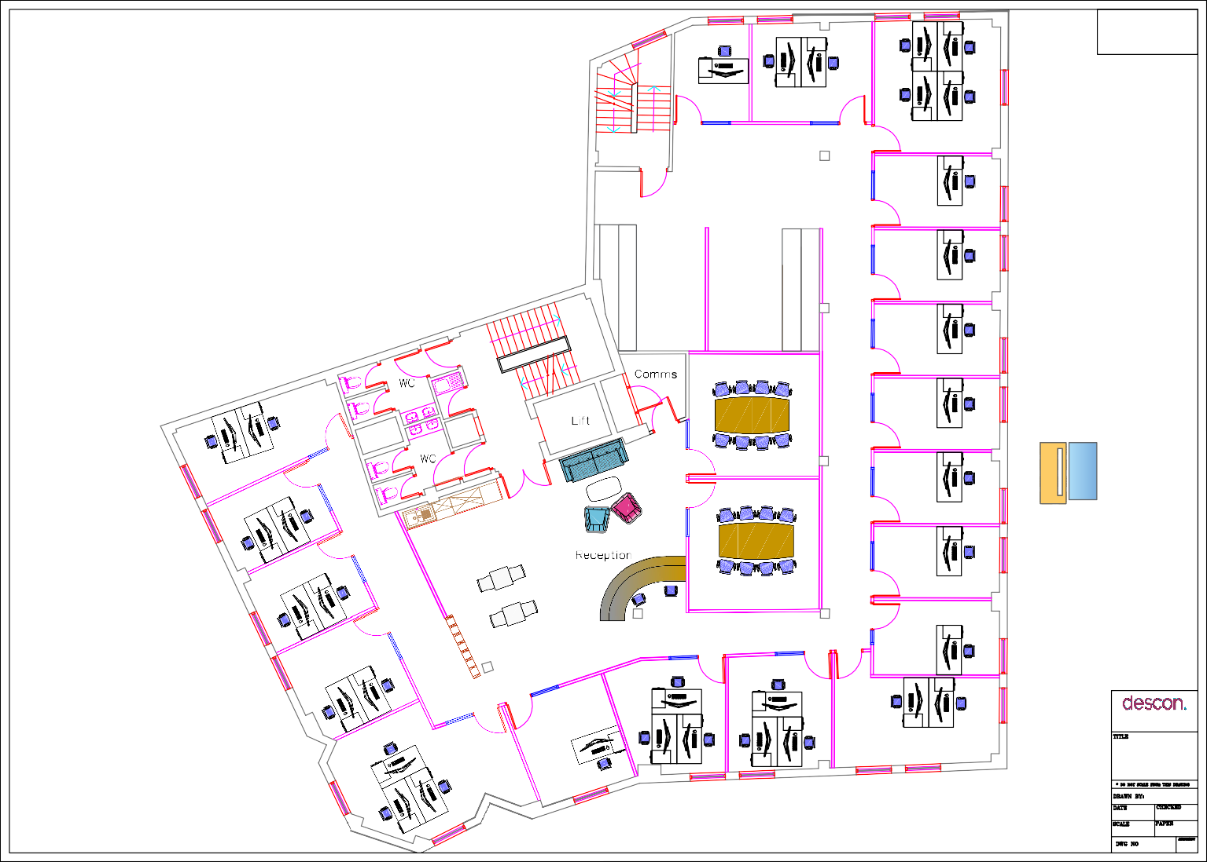

FD30s

Write on wall

Room divider

Working with Space
DESIGN HOUSE, TROMODE, ISLE OF MAN. IM4 4RG
TEL: (01624) 616939, FAX: (01624) 611177

Hubb First Floor

TRW

13.05.19

1:100 A3

09.12.19

