
TO LET – NEW INDUSTRIAL UNIT
Approx. 2,025 sq ft – £28,350 per annum + VAT Available from July 2026

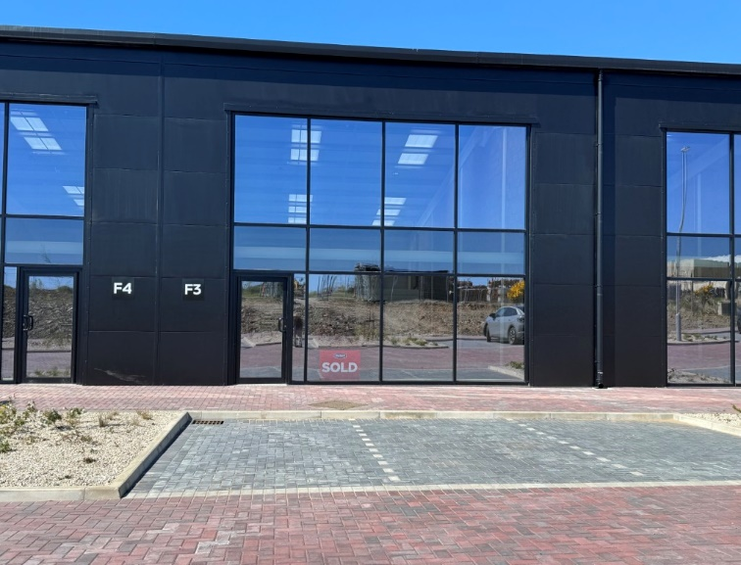
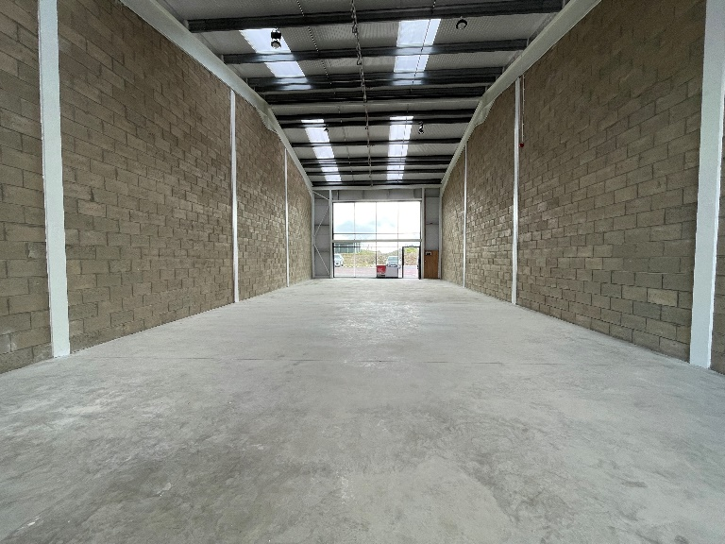
Unit F3, Eden Business Park, Braddan

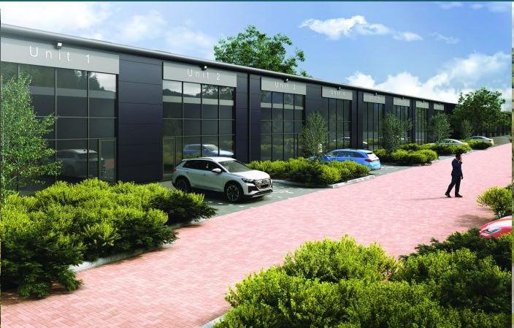
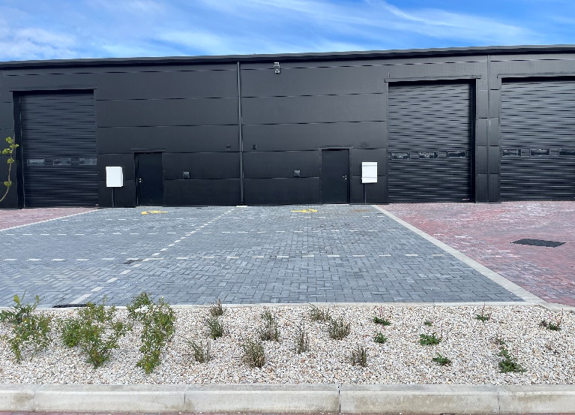

(CGI Image - once habitat planting is established)
- Fabulous opportunity to lease this brand new purpose-built unit on the much sought-after Eden Business Park Estate in Braddan. Glass fronted, with electric roller shutter at the rear.
- Unit F3 is located in the newest phase recently completed at Eden Park.
- Contemporary and sustainable design within an exceptional working environment - including high thermal performance. The design and infrastrure allow for easy installation of solar panels and EV charging points. There is also the benefit of fibre telecoms networks available.
- Toilet with shower, 3 phase electrics, an electric roller shutter door and 6 designated parking areas.
- Suitable for Light Industrial/Research & Development/Storage & Distribution.
- Eden Park is opposite the Isle of Man Business Park close to Douglas City Centre.

Over/…

LOCATION  Travelling out of Douglas on the New Castletown Road, turn right at the Cooil Road Roundabout onto Cooil Road. Continue through the next roundabout past Jacksons where the entrance to Eden Park is the second turning on the left.  Continue forwards past Riley’s Garden Centre, continue past the following block (Phase 1), and Unit F3 can be seen on the right hand side.  LEASE TERMS/REPAIRING OBLIGATIONS  A new lease is available on standard Full Repairing and Insuring terms. Tenant to pay building insurance and rates in addition.  RENT REVIEWS  Standard three yearly upward only rent reviews. |  | DIRECTOR’S GUARANTEE/DEPOSIT  A Director’s guarantee will be required if the lease is being taken in the name of a Limited Company. A 3 month rental deposit will be payable upon signing of the lease and will be returnable upon satisfactory expiry of the lease.  SERVICES  Mains services are installed.  TENURE  Vacant possession on completion of legal formalities.  LEGAL FEES  Each party to pay their own legal fees.  VIEWING  Strictly by appointment through Black Grace Cowley.


Sharon Gelling
Commercial Department
01624 645550
sharon@blackgracecowley.com
Ben Quayle
Commercial Department
01624 645550
ben@blackgracecowley.com

Black Grace Cowley Limited
Details of Black Grace Cowley can be viewed on our website blackgracecowley.com
This document is for general informative purposes only. The information in it is believed to be correct, but no express or implied representation or warranty is made by Black Grace Cowley as to its accuracy or completeness, and the opinions in it constitute our judgement as of this date but are subject to change. Reliance should not be placed upon the information, forecasts and opinions set out herein for the purpose of any particular transaction, and no responsibility or liability, whether in negligence or otherwise, is accepted by Lambert Smith Hampton or by any of its directors, officers, employees, agents or representatives for any direct, indirect or consequential loss or damage which may result from any such reliance or other use thereof. All rights reserved. No part of this publication may be transmitted or reproduced in any material form by any means, electronic, recording, mechanical, photocopying or otherwise, or stored in any information storage or retrieval system of any nature, without the prior written permission of the copyright holder, except in accordance with the provisions of the Copyright Designs and Patents Act 1988. Warning: the doing of an unauthorised act in relation to a copyright work may result in both a civil claim for damages and criminal prosecution.

