
TO LET
BRAND NEW INDUSTRIAL UNIT – £7,600 pa + VAT - Approx 760 sq ft



Unit 36, Balthane Park, Ballasalla

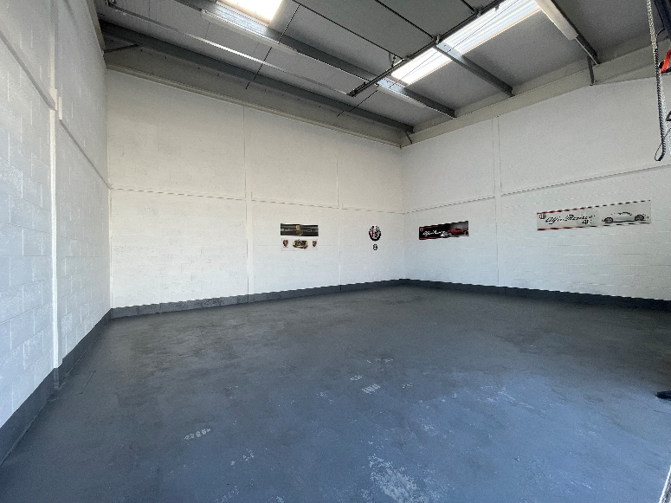
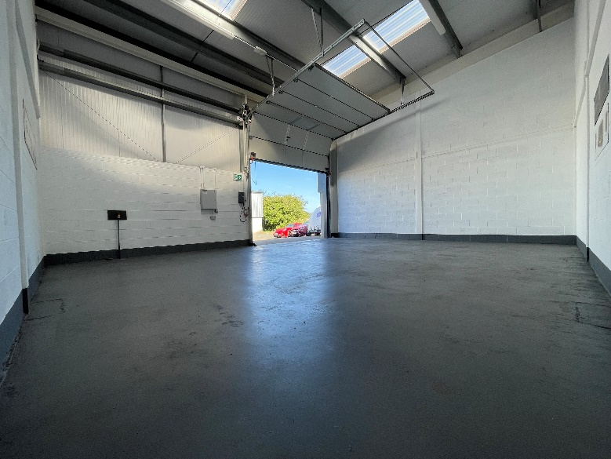

- Modern Industrial Unit available to let – approx 760 sq ft.
- Conveniently located on the popular Balthane Industrial Estate, Ballasalla.
- Electrically operated, insulated sectional overhead door with integral pedestrian door. Foul drainage infrastructure is in place for the installation of a toilet if required (subject to Landlord’s approval).
- The floor has been painted with commercial standard paint.
- 3 phase electrics. Foul drainage in situ ready for installation of WC facilities.
- Allocated car parking.

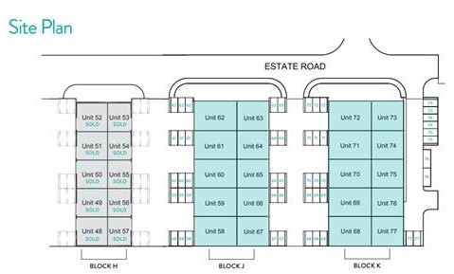
Over/…
DESCRIPTION  Great opportunity to take a lease of a modern Industrial Unit on the popular Balthane Park Development.  LOCATION  Balthane Park is ideally located close to Ronaldsway Airport and only 15 minutes from the centre of Douglas. Travelling into the Balthane Industrial Estate in Ballasalla, take the first left hand turn after Athol Garage. Continue down this road where the development can be found on the right-hand side. Each unit is clearly numbered.  LEASE TERMS/REPAIRING OBLIGATIONS  New leases are available on standard FRI terms via a service charge. Tenant to pay rates and building insurance in addition. |  | RENT REVIEWS  Standard three yearly upward only rent reviews.  DEPOSIT  A 3 month rental deposit will be payable upon signing of the lease and will be returnable upon satisfactory expiry of the lease.  SERVICES  Mains services are installed.  TENURE  Vacant possession on completion of legal formalities.  LEGAL FEES  Each party to pay their own legal fees.  VIEWING  Strictly by appointment through Black Grace Cowley.


Sharon Gelling
Commercial Department
01624 645550
sharon@blackgracecowley.com
Ben Quayle
Commercial Department
01624 645550
ben@blackgracecowley.com

Black Grace Cowley Limited
Details of Black Grace Cowley can be viewed on our website blackgracecowley.com
This document is for general informative purposes only. The information in it is believed to be correct, but no express or implied representation or warranty is made by Black Grace Cowley as to its accuracy or completeness, and the opinions in it constitute our judgement as of this date but are subject to change. Reliance should not be placed upon the information, forecasts and opinions set out herein for the purpose of any particular transaction, and no responsibility or liability, whether in negligence or otherwise, is accepted by Black Grace Cowley or by any of its directors, officers, employees, agents or representatives for any direct, indirect or consequential loss or damage which may result from any such reliance or other use thereof. All rights reserved. No part of this publication may be transmitted or reproduced in any material form by any means, electronic, recording, mechanical, photocopying or otherwise, or stored in any information storage or retrieval system of any nature, without the prior written permission of the copyright holder, except in accordance with the provisions of the Copyright Designs and Patents Act 1988. Warning: the doing of an unauthorised act in relation to a copyright work may result in both a civil claim for damages and criminal prosecution.

